10 Days Group:
  - $600.00

Challenge
Build a Mobile Maker Cart
Why:
Who:
Where:
What:
When:
How:

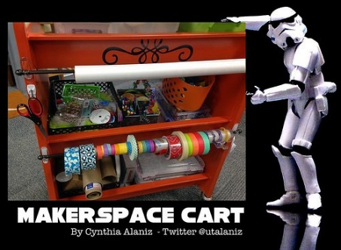
Name: __________________
Block: _______
Grade 8 DMI Project: Design a Maker Cart
Big Idea: Design can be responsive to identified needs (i.e. prototyping and testing).
The Project in Brief
Driving Question: How can we re-purpose a cart to meet the needs of the user?

Challenge #1

Do your Research / Empathy:
- Interview/Survey users about their experience with working/learning spaces.
- Dive deep: think about how the users feel.
- Reflect on personal experiences.
- Use Agency by Design's Think Feel Care routine (PDF).
- This step will take One class period plus homework.

Challenge #2

Define the Problem:
- What are the issues with our current working/learning spaces?
- Create a problem statement (such as, "How might we. . . ?").
- Develop a Thematic Cart (Tinker, Craft, Construction, Electronic, Digital etc.)
- This step will take One class period.

Challenge #3

Brainstorm and Prototype:
- In five minutes, think of as many solutions for your problem as possible.
- Choose one or more to prototype.
- Include a budget
- Source out
- Materials must have longevity-easy to replace
- Find a Mentor to guide you.
This step will take One class period plus homework.

Feedback / Test:
- Return to users for feedback on the prototype.
- Does this prototype solve the problem?

Reiterate:
- Incorporate feedback into your prototype.

Challenge #4

Final Build:
- Now that you've received feedback and reiterated your piece to reflect that feedback, build it!
- Sketch it out! Don't forget to use Digital Tools (e.g. Google Sketch-Up). Continue to test by asking, "Does this work? Do we need to make adjustments?"
- Include a budget
- This step will take One class period.

Challenge #5

Pitch:
- Maker Faire- May 26 Thursday
- Present Prototype for voting
- Present your design to a panel, which includes the principal, teachers, experts, and other administrators. Real audience members add authenticity.
- Include a Task List for students to partake
- This step will take One class period.

Challenge #6

Build a Mobile Maker Cart

Apply tasks pertaining to sign-up List

Everyone should have a task to perform

Use materials supplied

Reflect / Discuss:
- Review the experience of using design thinking to work with real users and real problems.
- Consider the process of building and reiterating. Was it frustrating when something didn't work?
- How can we redefine failure?
- What did the homework involve, and how did it help?

http://www.edutopia.org/blog/architecture-psychology-furniture-fallon-plunkett-lisa-yokana?utm_source=facebook&utm_medium=socialflow

