10 Days Group:
  - Product Deconstruction

Challenge
Deconstruct a Product of your choice

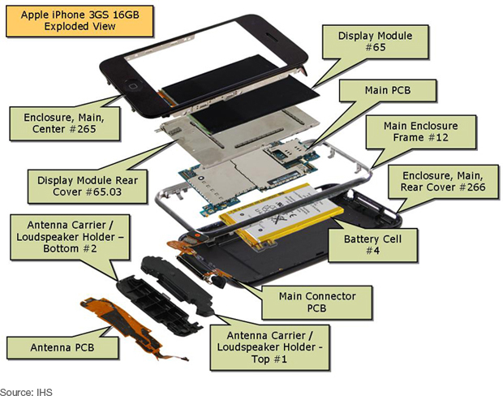
Touch image
Your Creative Challenge is to investigate, create and share interactive images that explore the hidden side of the things we use everyday by deconstructing products and analysing them.
Steps at a Glance:
- Select a product that you don’t mind breaking apart – double check with the owner if you are not sure.
- Photo-Document the process
- Carefully (and safely) take it apart. Keep all the parts and lay them out.
The screen on the iPhone is made from special glass called Gorilla Glass because it is hard (it won’t scratch easily) and tough (it won’t shatter).

- Take a photo.
  - Take a look at Todd McLellan’s photos, Things Come Apart for more inspiration.
  - Learn How to Take Awesome Photos from iFixitEDU.
- Use ThingLink rich media tags to make your image come alive!

Reflect / Discuss:
- Review the experience of using design thinking to work with real users and real problems.
- Consider the process of building and reiterating. Was it frustrating when something didn't work?
- How can we redefine failure?
- What did the homework involve, and how did it help?

Criteria:
Each annotation should include
- A tag to identify the participating teacher and student designers.
- A tag to identify each part of the product.
- Information about what material the product is made of.
- A justification for use of the material. This should use the word “because."

Follow Up
Try to put the product back together. If that’s not possible, please be responsible and recycle it.

